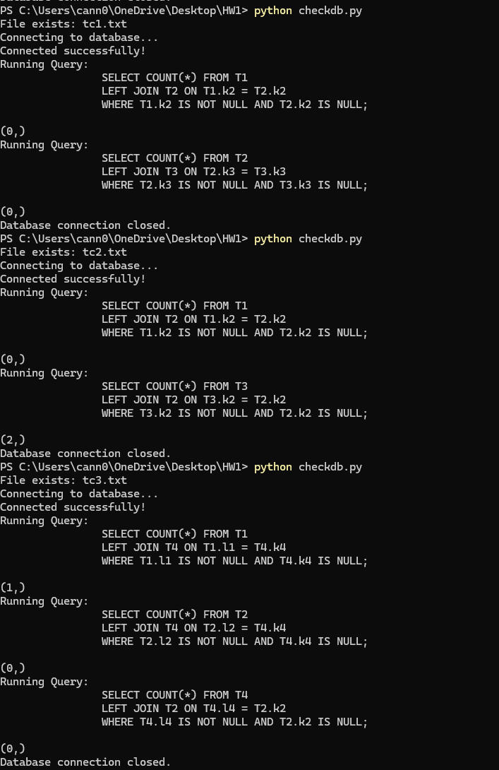

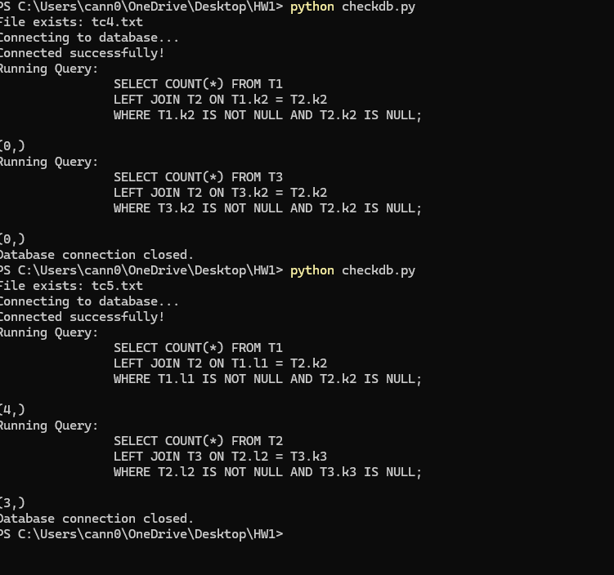

Tc1.txt  
  
 SELECT COUNT(\*) FROM T1

LEFT JOIN T2 ON T1.k2 = T2.k2

WHERE T1.k2 IS NOT NULL AND T2.k2 IS NULL;

SELECT COUNT(\*) FROM T2

LEFT JOIN T3 ON T2.k3 = T3.k3

WHERE T2.k3 IS NOT NULL AND T3.k3 IS NULL;

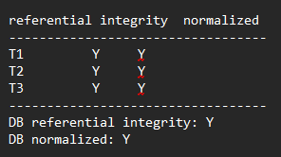

Tc2.txt  
  
 SELECT COUNT(\*) FROM T1

LEFT JOIN T2 ON T1.k2 = T2.k2

WHERE T1.k2 IS NOT NULL AND T2.k2 IS NULL;

SELECT COUNT(\*) FROM T3

LEFT JOIN T2 ON T3.k2 = T2.k2

WHERE T3.k2 IS NOT NULL AND T2.k2 IS NULL;

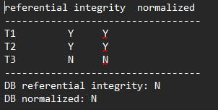

Tc3.txt

SELECT COUNT(\*) FROM T1

LEFT JOIN T4 ON T1.l1 = T4.k4

WHERE T1.l1 IS NOT NULL AND T4.k4 IS NULL;

SELECT COUNT(\*) FROM T2

LEFT JOIN T4 ON T2.l2 = T4.k4

WHERE T2.l2 IS NOT NULL AND T4.k4 IS NULL;

SELECT COUNT(\*) FROM T4

LEFT JOIN T2 ON T4.l4 = T2.k2

WHERE T4.l4 IS NOT NULL AND T2.k2 IS NULL;

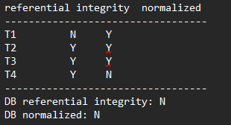

Tc4.txt

SELECT COUNT(\*) FROM T1

LEFT JOIN T2 ON T1.k2 = T2.k2

WHERE T1.k2 IS NOT NULL AND T2.k2 IS NULL;

SELECT COUNT(\*) FROM T3

LEFT JOIN T2 ON T3.k2 = T2.k2

WHERE T3.k2 IS NOT NULL AND T2.k2 IS NULL;

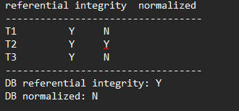

Tc5.txt

SELECT COUNT(\*) FROM T1

LEFT JOIN T2 ON T1.l1 = T2.k2

WHERE T1.l1 IS NOT NULL AND T2.k2 IS NULL;

SELECT COUNT(\*) FROM T2

LEFT JOIN T3 ON T2.l2 = T3.k3

WHERE T2.l2 IS NOT NULL AND T3.k3 IS NULL;

